EXPLAINABLE ARTIFICIAL INTELLIGENCE (XAI) FOR THE DETECTION AND SEGMENTATION OF MASS ON MAMMOGRAMS USING DEEP LEARNING TECHNIQUES
Ho-Dat TRAN^{1,2}, Thuong-Cang PHAN¹, Vinh-Phong NGUYEN³, Tri-Nghia Phu⁴, Anh-Cang PHAN²
¹Can Tho University, datth@vlute.edu.vn, ptcang@cit.ctu.edu.vn
²Vinh Long University of Technology Education, cangpa@vltue.edu.vn
³Can Tho Oncology Hospital, dr.vinhphong86@gmail.com
⁴Can Tho University of Medicine and Pharmacy, ptnghia@ctump.edu.vn
cangpa@vlute.edu.vn

Abstract. Breast cancer is the leading cause of death among women in Vietnam and around the world. Currently, with the advancement of deep learning techniques, AI-based diagnostic systems have shown significant accuracy in breast cancer classification, helping to improve treatment effectiveness. However, most deep learning models are complex, difficult to explain, and do not provide much information in making decisions. Explainable AI (XAI) techniques provide the ability to explain deep learning models in medical diagnosis to clarify important features in decision-making. This paper proposes an effective method for the detection and segmentation of mass on mammograms based on deep learning techniques that integrate the global explanation methods LIME and SHAP to enhance reliability and support effective decision-making. According to experimental results, the suggested approach uses a test dataset gathered from multiple nearby hospitals and achieves 96% accuracy with an RMSE of 0.017. These results highlight the effectiveness of the proposed model in improving diagnostic accuracy and provide important information in interpreting the output of deep learning models, laying the foundation for further studies in improving the quality of early-stage cancer detection.
Keywords: breast cancer, XAI, deep learning.
1 Introduction
In both emerging and developing nations, breast cancer continues to be the leading cause of cancer-related mortality. The WHO predicts that by 2025, there will be more than 19.3 million additional cases globally[1]. Accurate classification and early discovery are crucial because they enable patients to receive the right treatments, which may reduce death rates. About 2.1 million women are diagnosed with breast cancer annually, making it the most common cancer in women and a major cause of cancer-related fatalities. Reducing needless surgical procedures and enhancing patient outcomes depend on the preoperative detection of breast cancer and its subtypes. The main diagnostic method is mammography, which helps identify anomalies such as masses, calcifications, structural deformities, and asymmetries.
The diagnosis of breast cancer has changed dramatically as a result of the use of artificial intelligence (AI) into medical imaging. Convolutional Neural Networks (CNNs), a type of deep learning technique, exhibit great classification accuracy. However, clinical acceptance is hampered by their black-box character. This problem is addressed by Explainable AI (XAI), which offers comprehensible insights into model predictions. Local Interpretable Model-Agnostic Explanations (LIME) is a technique that was introduced by Ribeiro et al.[2]. Its purpose is to explain black-box models by utilizing interpretable models to approximate their behavior locally. LIME approximates the original model's decision boundary by creating perturbations around an instance and fitting a basic surrogate model. The study showed how well LIME explains predictions from deep learning models by applying it to a variety of datasets, including text and image classification tasks. SHapley Additive exPlanations (SHAP), a technique based on cooperative game theory, was created by Lundberg et al.[3]. It gives each feature an importance score according to how much it contributes to the model's predictions. Because SHAP guarantees local correctness and consistency, the model output for every instance is equal to the sum of SHAP values. SHAP ensures consistency in feature attributions by providing both local and global interpretability. It offers a consistent metric for feature relevance across various model kinds.
This study examines the segmentation capabilities of deep learning models through interpretability based on several XAI techniques, provides a framework to improve interpretability, and evaluates how it affects segmentation performance.
2 Background
2.1 U-Net
Ronneberger et al.[4] created U-Net, which is mostly used for picture segmentation. The U-Net architecture is constructed as a symmetric network with two expansion and contraction pathways. Comparable to a standard convolution network, the contraction path also referred to as the encoder in the left block provides classification data. The expansion path uses deconvolution layers to learn and segment; it is also referred to as the decoder in the right block. Two blocks of the same level are connected by short connections to prevent information loss during convolution and deconvolution. In order to identify the features of the image for learning, the contraction does the feature extraction task. However, by employing convolutions and pooling layers to produce feature maps with increased resolution, it also reduces the image's size. The network can now learn localized classification information thanks to the extension.
2.2 DeepLabV3+
L.-C. Chen et al.[5] presented DeepLabV3+, a sophisticated convolutional neural network architecture for semantic segmentation. To enhance edge resolution and multi-scale context, the model successfully integrates the encoder–decoder architecture with the Atrous Spatial Pyramid Pooling (ASPP) mechanism. While retaining the encoder-decoder architecture, DeepLabV3+ employs independent convolution to lower computational cost and improves context extraction with ASPP. The backbone (encoder), ASPP, and decoder are the three primary parts of the network.
2.3 Explainable artificial intelligence (XAI)
Artificial intelligence (AI) applications and research have advanced significantly as a result of Deep Neural Networks' (DNNs) success. Despite their enormous success, the majority of machine learning algorithms are only partially able to explain their results; consumers are unaware of the neural network's reasoning behind a given choice. Consequently, the capacity to decipher AI models is essential. XAI combines methods and technologies that enable people to analyze and interpret deep learning model outputs. It lets people join AI's decision-making processes and can halt or manage its operations as needed. In addition to doing certain jobs efficiently, an AI system should be able to transparently report on how and why it completed the task.
- Common Techniques in XAI Global Model Interpretability: This method aims to provide a comprehensive explanation of the entire model. For instance, it makes use of user-friendly, straightforward models like decision trees and linear regression.
- Local Model Interpretability: This method only explains particular predictions rather than the model as a whole. Two common approaches are SHAP (SHapley Additive exPlanations) and LIME (Local Interpretable Model-agnostic Explanations).
- Visualizations: To show which aspects of the data affect the outcomes, use charts or visual representations (like heatmaps in image recognition algorithms).
2.4 Evaluation metrics
We employ a number of model evaluation indicators to assess the suggested model's performance. The ratio of accurately identified instances (true positive and true negative) to the total number of real instances is known as accuracy (Eq. 1). The loss measure in segmentation models is typically made to represent the discrepancy between the label and the expected outcome. The objective is to enhance the model's performance by minimizing the loss function. We employ measurements for accuracy and loss derived from Eq. 2 and Eq. 4
$$Acc=\frac{TP+TN}{TP+TN+FP+FN}$$ | (1) | $$IoU=\frac{Area of Overlap}{Area of Union}$$ | (2)
$$Dice_coef=\frac{2|Prediction ∩Ground Truth|}{\left|Prediction\right|+|Ground Truth|}$$ | (3) | $$Dice_{Loss}=1-Dice_coef$$ | (4)
$$RMSE= \sqrt{MSE}=\sqrt{\frac{1}{n}\sum_{i=1}^{n}{{\left(u_{i}-\hat{u_{i}}\right)}^{2}}}$$ |  |  | (5)
In addition, we also evaluate the segmentation efficiency by RMSE and MSE indexes according to the formula Eq. 5 where u_{i} is the ground truth at pixel 𝑖, $\hat{u_{i}}$ is the predicted value at pixel 𝑖 out of total number of pixels n.
3 Proposed method
The general model we propose in this paper is shown in Fig. 1 and consists of three stages: (1) preprocessing to generate input data for the deep learning model, (2) features extraction and training, and (3) segmentation and interpretation using XAI techniques.
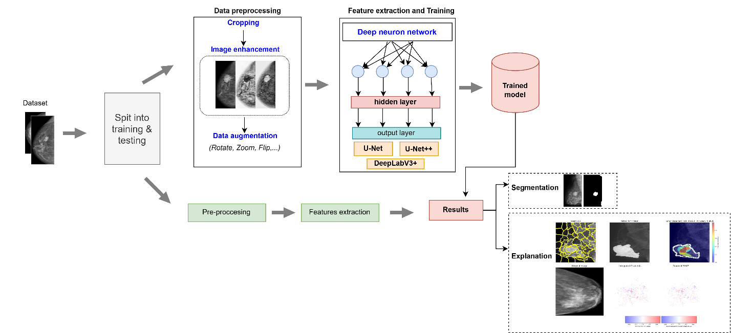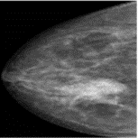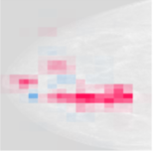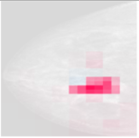

Fig. 1 A general model is proposed for breast cancer segmentation using XAI technique.

3.1 Data preprocessing: Input images will undergo normalization, be stored in .jpg format, and be resized appropriately for the proposed models. Image preprocessing involves normalizing image size, cropping to eliminate background, and enhancing images through histogram and Gaussian algorithms. Additionally, data enhancement techniques including: zooming, rotating, and flipping are employed to augment the training dataset.

3.2 Features extraction: Following preprocessing, the image will be subjected to feature extraction, detection, and mass segmentation. Feature extraction involves utilizing weights from trained models through transfer learning techniques, followed by fine-tuning to minimize the loss value. The training process will cease when the loss value ceases to improve. The trained models will be derived from the input dataset.

3.3 Testing phase: Following feature extraction, the dataset images are processed through the trained models to produce the corresponding outputs. The model output comprises segmentation results and output images associated with the SHAP, LIME values. The model evaluation metrics outlined in Section 2 are utilized to assess the performance of the segmentation model. This approach guarantees that the final output is accurate and reliable, offering valuable insights for further analysis. For the proposed model, we conduct experiments under four scenarios with the following training parameters:

Tab. 1 Recommended scenarios and training parameters.
Sce. | Model | Epochs | Batch size | Learning rate
1 | U-Net | 100 | 32 | 0.0001
2 | U-Net++ | 100 | 32 | 0.0001
3 | DeepLabV3+ | 100 | 32 | 0.0001
4 Experimental results
4.1 Installation environment and dataset
The system uses an Intel Xeon 2.00 GHz processor with 30GB of RAM and runs in a Python environment on Kaggle. It also makes use of the Nvidia Tesla P100 GPU and a graphics processor with 16GB of RAM. The package used to train network models is called Tensorflow v1.5. In the paper, we use the VinDr dataset[6] and we supplement it by collecting data from some local hospital. The data is then labeled and classified by specialist doctors. A total of 493 normal images, 310 malignant images, and 242 benign images are used in the paper. The 70:30 ratio is used to partition the dataset.
4.2 Training results
Based on the proposed model, we compare and evaluate the evaluation metrics presented in Section 2. The results are presented in Tab.2.

Tab. 2 Model performance evaluation results
Sce. | Model | Loss | Dice | IoU | F1-Score | RMSE | MSE | Acc
1 | U-Net | 0.1951 | 0.93 | 0.91 | 0.92 | 0.017 | 0.0003 | 0.96
2 | U-Net++ | 0.2541 | 0.88 | 0.80 | 0.87 | 0.026 | 0.0007 | 0.92
3 | DeepLabV3+ | 0.2485 | 0.92 | 0.86 | 0.91 | 0.02 | 0.0004 | 0.93
The evaluation results of 3 scenarios indicate a generally good overall performance, with accuracy (Acc) ranging from 0.92 to 0.96. The U-Net model achieved the highest accuracy score (0.96) along with impressive metrics for Dice (0.93), IoU (0.91), and F1-Score (0.92). It also recorded very low RMSE and MSE values (0.017 and 0.0003), demonstrating its superior effectiveness in image segmentation. In contrast, U-Net++ and DeepLabV3+ exhibited slightly lower accuracy (0.92-0.93), with DeepLabV3+ achieving the lowest Loss value (0.2485) but a somewhat higher RMSE (0.026). Overall, U-Net stands out as the best model for this dataset, while DeepLabV3+ shows potential for improvement due to its low loss value.
4.3 Explainable results
The Grad-CAM results of the three scenarios show how the models focus on areas to make predictions. In the Grad-CAM heatmaps, red/yellow areas represent areas that have the greatest influence on the model's decision, while blue indicates low influence. With Sce. 1, the heatmap focuses precisely on the suspect areas in the image, with the red/yellow areas covering evenly and clearly. Sce. 3 also focuses on similar areas, but the red/yellow areas are somewhat scattered and uneven, reflecting lower performance. Meanwhile, Sce. 2 shows a rather narrow and inconsistent red/yellow focus, especially in the second and third rows, which explains why the model has a higher RMSE and lower accuracy.
Input | Ground truth | U-Net | U-Net++ | DeepLabV3+
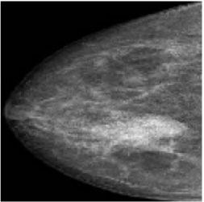 |  | 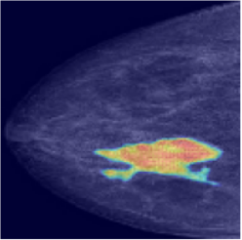 | 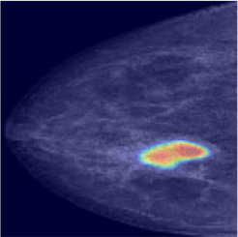 | 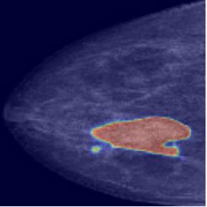
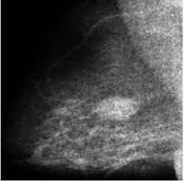 |  | 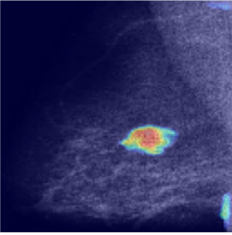 | 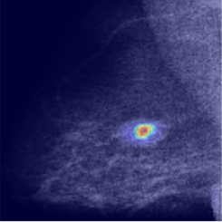 | 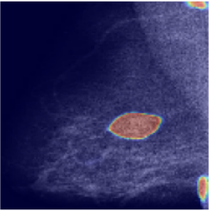
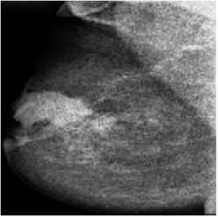 |  | 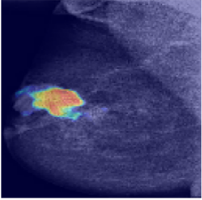 | 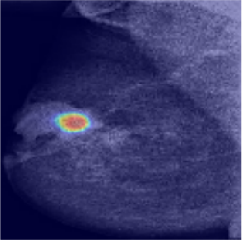 | 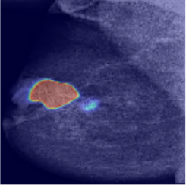

Fig. 2 XAI Grad-Cam interpretation results of the 3 algorithms
Input | Ground truth | U-Net | U-Net++ | DeepLabV3+
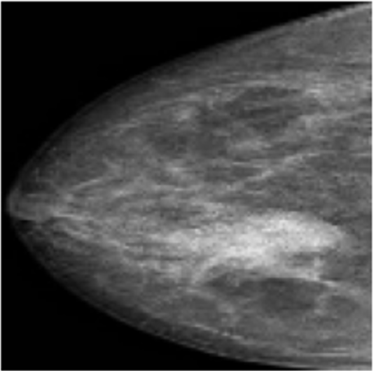 |  | 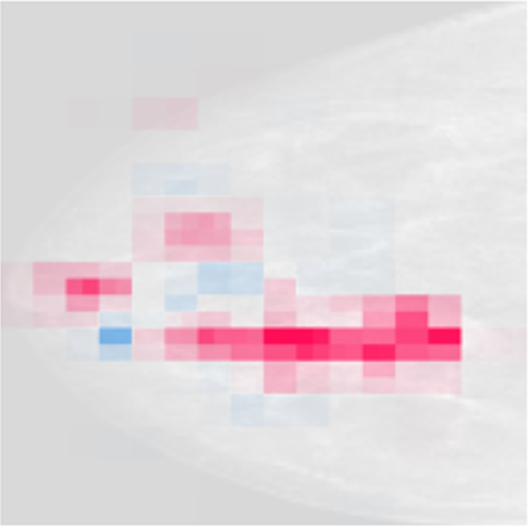 | 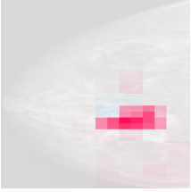 | 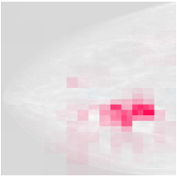
 |  | 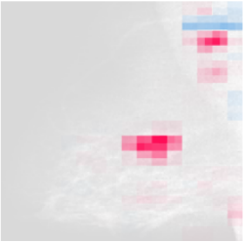 | 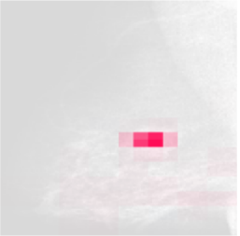 | 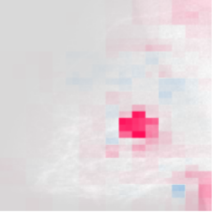
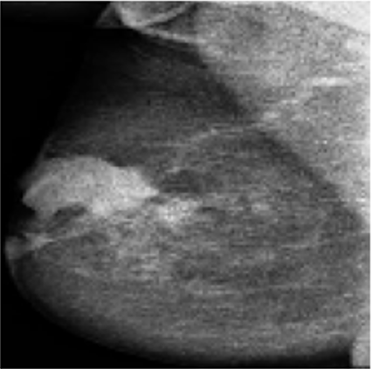 |  | 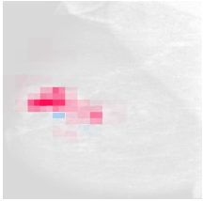 | 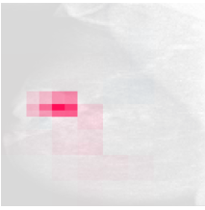 | 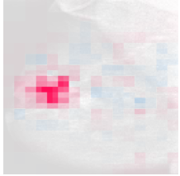
 |  | 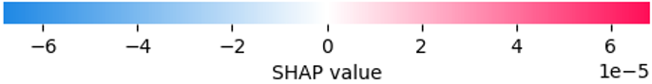
Fig. 3 Results explained by SHAP technique
The SHAP results of the three scenarios on the input images show how each model focuses on image regions for prediction. In the SHAP images, red represents regions that have a strong positive impact on the model's prediction, while blue represents a negative impact. Sce. 1 tends to focus precisely on suspicious regions (bright red regions), indicating a good ability to detect the mass region. Sce. 3 also focuses on similar regions, but the red distribution is lighter, indicating a lower level of confidence, consistent with the lower IoU and F1-Score (0.86 and 0.91). Meanwhile, Sce. 2 has a rather scattered, uneven red concentration, which explains why this model has a higher RMSE (0.02) and slightly worse overall performance than the other two scenarios.
 | Input | Seg. | LIME
U-Net | 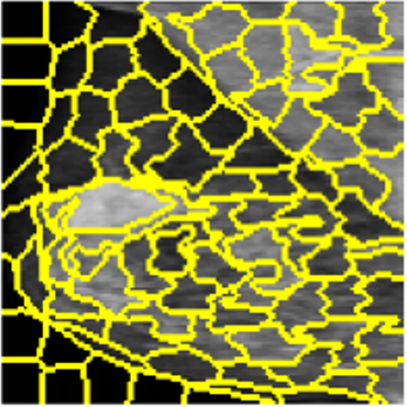 | 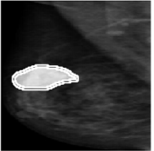 | 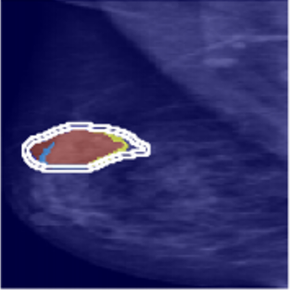
U-Net++ |  | 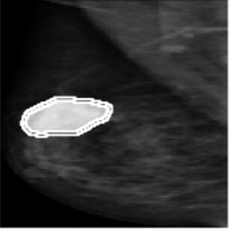 | 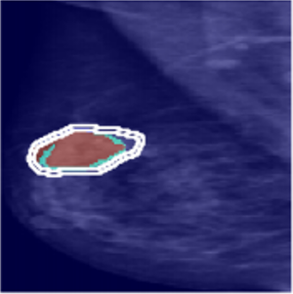
DeepLabV3+ | 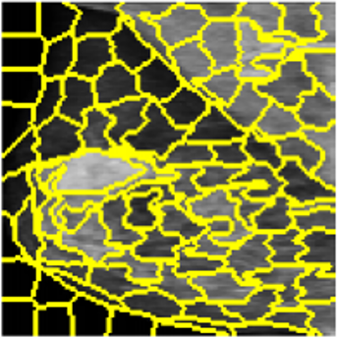 | 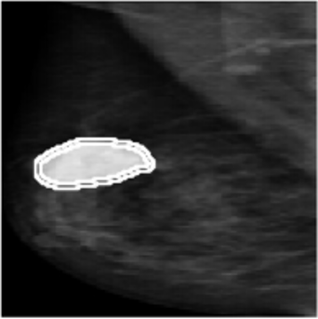 | 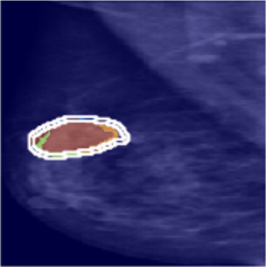
Fig. 4 Results explained by LIME technique
The LIME technical results are shown for the three scenarios, providing information on how the models make predictions. In the heatmap, yellow and red represent areas with positive influence on the prediction (high contribution), while blue or purple represent negative influence. For Sce. 1, all three models show that LIME produces clear contours over the influence areas and is well concentrated around the target area. For Sce. 3, the LIME results are also concentrated around the target area and are evenly distributed, consistent with the model performance. In Sce. 2, the LIME algorithm correctly identifies the mass area, but the region of interest is narrower than in the above two scenarios, reflecting a lower segmentation ability than in Scenarios 1 and 2.
5 Conclusion
In the paper, we propose an effective method for segmenting mass on mammograms using U-Net, U-Net++, and DeepLabV3 algorithms. Through the training and experimentation process, the models have proven to be effective in extracting abnormalities on mammograms with the accuracy achieved on the IoU and Dice indexes reaching 91% and 93%, respectively. In addition, the integration of XAI algorithms helps users better understand the process of deep learning networks giving results. According to the experimental result, the model achieves an MSE index of 0.0003 and RMSE of 0.017, demonstrating its effectiveness in identifying mammograms and minimizing errors in the output results. In the future, we will continue to develop a normal, benign, and malignant classification model to build a complete system to effectively support doctors in timely diagnosis and treatment to improve health care.
References
[1] World Health Organization. WHO guidelines for screening and treatment of precancerous lesions for cervical cancer prevention. World Health Organization (2021).
[2] Ribeiro, Marco Tulio, Sameer Singh, and Carlos Guestrin. "Why should i trust you?" Explaining the predictions of any classifier." Proceedings of the 22nd ACM SIGKDD international conference on knowledge discovery and data mining (2016).
[3] Lundberg, Scott M., and Su-In Lee. "A unified approach to interpreting model predictions." Advances in neural information processing systems 30 (2017).
[4] Ronneberger, Olaf, Philipp Fischer, and Thomas Brox. "U-net: Convolutional networks for biomedical image segmentation." International Conference on Medical image computing and computer-assisted intervention. Cham: Springer international publishing (2015) 234–241.
[5] Chen, Liang-Chieh, et al. "Encoder-decoder with atrous separable convolution for semantic image segmentation." Proceedings of the European conference on computer vision (ECCV) (2018).
[6] Pham, Hieu Huy, H. Nguyen Trung, and Ha Quy Nguyen. "Vindr-mammo: A large-scale benchmark dataset for computer-aided detection and diagnosis in full-field digital mammography." Sci Data (2022).

